**One - Stage Reduction Gearbox Technical Report**

Table of Contents

***Title and Abstract*** ***4***

Executive Summary 4

***Introduction*** ***4***

**Synthesis and Decision on General Layout** **7**

Single Stage Spur Gear 7

Single Stage Helical Gear 8

**Design Procedure and Sample Calculations** **9**

Gear Calculations: 9

Shaft Calculations: 13

Key Calculations: 17

Bearing Calculations: 19

**Discussion - Conclusions** **21**

Supporting Information to Determine the Conclusion: 22

Gear Design: 22

Pinion Shaft 23

Gear Shaft 25

Key 26

Bearing 27

References **28**

***Appendices*** ***30***

Appendix A: List of Symbols 30

Appendix B: Tables 32

Appendix C: Figures 40

Appendix C: Equations 44

# Title and Abstract

## Executive Summary

The designing of a single reduction gearbox was focused when conducting the implementation of the single reduction gear box project. Our group of ten members focused on designing a single reduction spur gearbox. Which includes a series of gears, shafts, bearings, keys, housing and mechanical keys and shafts that meet to the specification of our team. The objective of our team was to create a gearbox design that can handle 25 HP and an input speed of 1750 rpm and an output speed of 500 rpm.

The design of our gearbox was executed by the implementation of using Microsoft excel spreadsheets to create equations for each design component of the gearbox. The initial design of the gearbox was designed using solid works and the proper fixtures between the contact parts of housing and the connectors of bearing loads were executed through the simulation process.

# Introduction

The function of a gearbox is to transfer a portion of energy from one device into another device by increasing its torque. When creating our gearbox design our group focused on many key aspects of the gearbox.

The gear attachments were carefully considered when designing our solid works as the pinion and gears were fixed onto the shafts. When designing our gear components, the necessary factors of safety of the bending and wearing are calculated and determined to ensure a proper rotation of the gears.

A major design component in our gearbox was the creation of the shafts. When designing our shafts, the size of the shaft and the arrangement of the shaft assemblies were determined to judge location of the bearings. The creation of the shaft key in the gearbox was very critical as the input shaft key had to fail the ultimate shear strength before the gears or the shafts began to yield. Our group calculated the yielding and shear failure safety factors of the shaft keys. This calculation process ensures that the failure will occur in the weakest key initially as this prevents the rest of the gearbox from overloads.

The gearbox housing was another major component towards the designing process of our gear box. As the gearbox housing provided the necessary support of the bearing to ensure that all components of the gearbox are sealed and are properly fixed in place. As in our designing creation of our gearbox there were two mounted points assembled in the gearbox.

By using the software of solid works our group was able to properly design and assemble part modeling of our gear box design. Initially our group designed drawings of the shaft in order to get an outlook of the gearbox components. When creating our design and drawing a judgment of the necessary tolerances and dimensions were heavily measured and considered when developing our gearbox. Each of our drawings displayed clear information on the sizing of the shafts and the gears. With proper dimensions and drawings presented our group was able to efficiently start on the design modelling of solid works and the simulation process by assembling the necessary parts into the gearbox design.

The delivered power will be in the range 25 HP, and the input speed used for our gearbox is 1750rpm and the output speed is 500 rpm. The input and output shafts designed in our gearbox were 100mm long and were displayed on the slots of the outside of the gearbox.

The gear pressure angle for our design specification was at an angle of 20°, in our gearbox design a helix angle was not used. The design life for the gears and bearings were 20,000 hours of life.

In our gear box design two keys were developed using solid works software the formation of the gear and pinions were developed with the use of a yielding safety factor of ny 2. The fatigue safety factors for both the gears and pinions are 1.2. The bending of our pinion is 1.2 also, yet for the gear the bending was calculated to be 1.5.

In our gearbox design our group went with a diametral pitch of 6, with the data provided in the section 14-4 of the Shigley’s Mechanical Engineering Design eBook. The required measurements of the development of the gears and pinions used in the gearbox were collected from the figure and tables of 14-4 section.

In our gearbox design we were able to precisely mark the axial locations of the gears on the shaft. In the gearbox the motor shaft was required to couple with the input shaft for the proper assembly the input shaft measurements were taken to be extended over the housing component for a proper assembly connection with the motor shaft. For the output shafts of the gearbox the mates had to have a proper connection with the drive shaft in the propeller. With the correct tolerance and dimension used in the solid works software, our proper assembly of the gearbox was conducted. A design reliability of 0.999 was also used through the development of our gearbox design

When developing the gears component of our gearbox we ensured that the number of teeth in the gear stay at the limit of 75 to ensure proper rotational components can be established within the gearbox.

The diameters of our shafts used in the gearbox were 1 inch and the length of each shaft used were less than 10 inches to ensure that the shaft would fit into the gearbox. Each bearing used in the gearbox had a 95% reliability with a design life component of 20,000 hours.

The gears in the gearbox were at commercial quality of 99.9 reliability and the centre of distance marked between each gear had a separation distance of 10 inches in the gearbox from its center location.

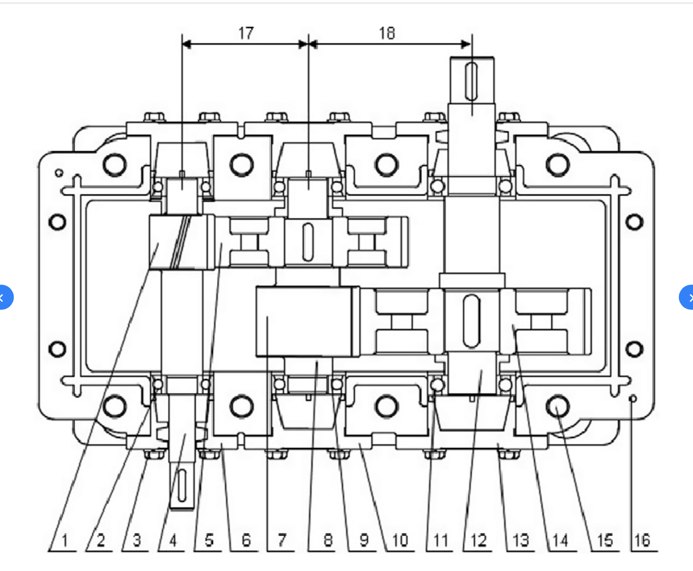

An example of gearbox layout

1. pinion; 2. bearing; 3. connecting bolt for bearing cover; 4. high speed shaft; 5. gear; 6. bearing cover; 7. pinion; 8. middle shaft; 9. bearing; 10. bearing cover; 11. bearing; 12. low speed shaft; 13. bearing cover; 14. gear; 15. housing connecting bolt; 16. guide pin; 17. high-speed stage center distance; 18. low-speed stage center distance.

# 

# Synthesis and Decision on General Layout

## Single Stage Spur Gear

When designing a one-stage speed reduction gearbox there were two various design choices that were presented. The option of using spur gear or helical gears was a critical design and ultimately designing our gear box. The differences and benefits of using one gear over another required our team members to gain a proper understanding of the two gears. When using spear gears in our gearbox there teeth are in a straight manner and the teeth are parallel to the axis of the gear. The spur gears when compared to the helical gears are very loud gears and the transmission of the gears are not the smoothers. The spur gears tend to produce a higher efficient power and this was one of the reasons our group tended to lean towards developing a gearbox that contained the use of spur gears. In the gearbox design the spur gear when in use at the higher power loads will vibrate and cause the noise of the gearbox to be heard in a loud manner when higher speeds are produced.

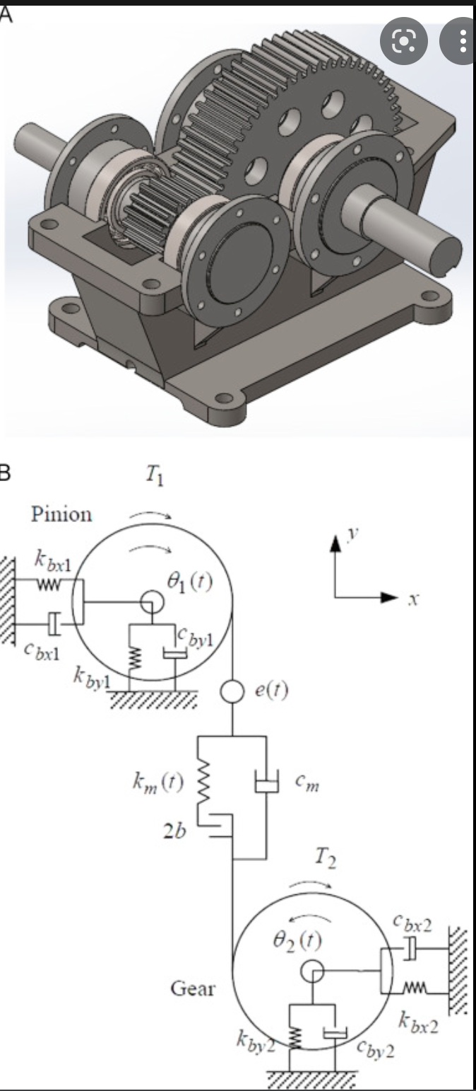

## Single Stage Helical Gear

The second option was using helical gears in our gearbox , our group initially gained a proper understanding of spur gears and their implication towards a gearbox. When studying the effects of helical gears instead of a gear box we were able to compare that in helical gears the teeth are arranged in an angle to the gears axis. The helical gears provided a more smoother and quieter operation compared to the spur gears in the gearbox design. Helical gears inside a gearbox have a higher load carrying capacity and thus creating a greater tooth strength for the gears teeth. The main difference in design layout between the two gears is that helical gears transmit power in between the parallel and the non parallel shafts. Spur gears only had the ability to transmit power to the parallel shafts. After analyzing and studying the design layout between the two gears our group tended to lean towards designing a single stage spur gearbox due to the gearbox’s ability to produce a high efficient power.

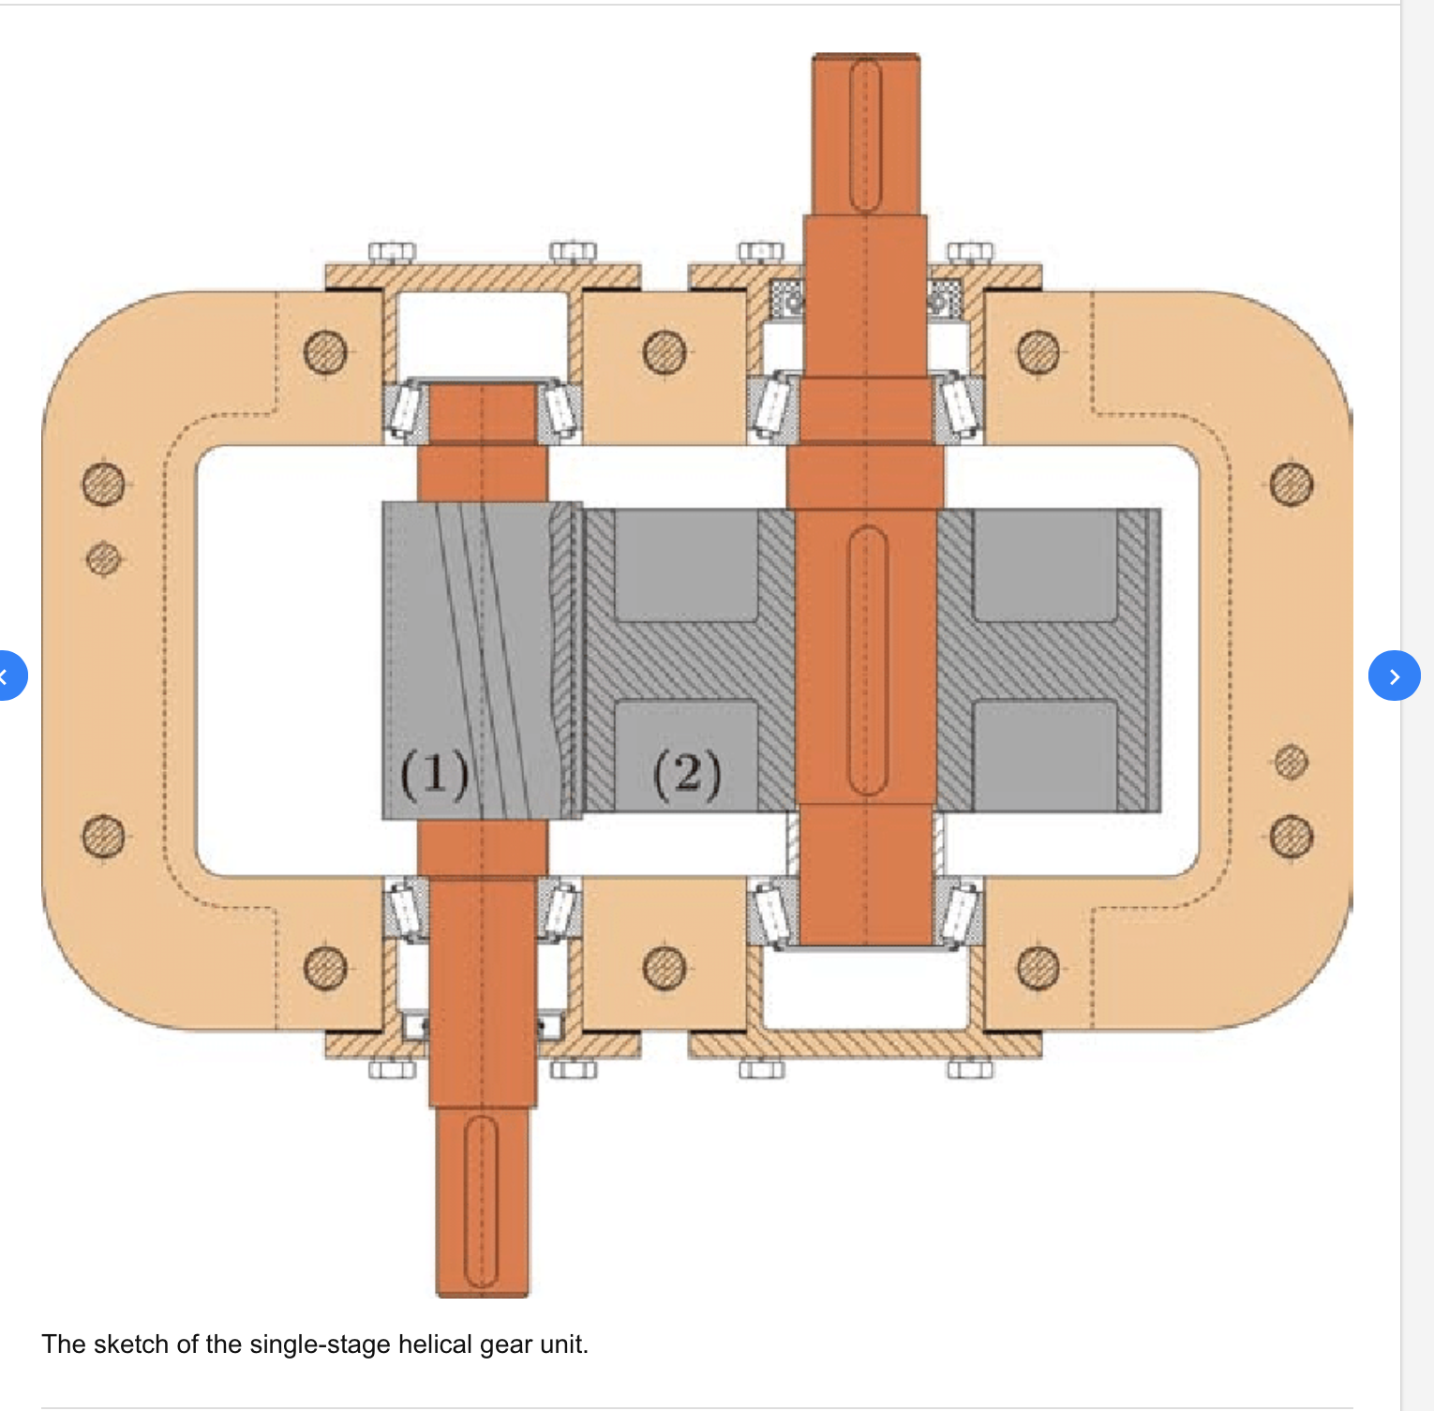

# Design Procedure and Sample Calculations

## Gear Calculations:

Design Procedure - First Iteration Parameters:

Pinion Teeth Number (Np) = 20

Gear Teeth Number (Ng) = 70

Material used: Gray Cast Iron Class 40

Diametral Pitch (Pd) = 4

Pressure Angle = 20°

Input Power (P) = 25 HP

Input Speed (n) = 1750 rpm

Output Speed = 500 rpm

Life (N) = 20,000 hours

Reliability = 99.9%

Gear Ratio (mg) = 3.5

Pinion Pitch Diameter:

𝑑𝑝 = 𝑁𝑝/𝑃𝑑 = 5

Gear Pitch Diameter:

𝑑𝑔 = 𝑁𝑔/𝑃𝑑 = 17.5

Pitch Line Speed:

𝑉 = (𝜋 ∗ 𝐷𝑝 ∗ 𝑛)/12 = 2290.74

Transmitted Load:

𝑊𝑡 = (33,000 ∗ 𝑃)/𝑉 = 360.14

Face Width Guidelines:

𝐹𝑚𝑖𝑛 = 8/𝑃𝑑 = 2 𝑖𝑛𝑐ℎ

𝐹𝑛𝑜𝑚 = 12/𝑃𝑑 = 3 𝑖𝑛𝑐ℎ

𝐹𝑚𝑎𝑥 = 16/𝑃𝑑 = 4 inch

Face Width/Pinion Diameter Ratio:

𝐹/𝐷𝑝 = 0.6

Elastic Coefficient: 1554.116

𝑣𝑝 = 0.211

𝐸𝑝 = 14.5 𝑀𝑝𝑠𝑖

Elastic Coefficient:

The elastic coefficient was calculated, using the values found in Table A-5.

𝐶𝑝 = ( 1 𝜋 ∗ (1 − 𝑣𝑝^2 )/𝐸𝑝 + (1 − 𝑣𝑔^2 )/𝐸𝑔 ) 0.5

Poisson's Ratio for Gray Cast Iron: 𝑣 = 0.211

Modulus of Elasticity for Gray Cast Iron: 𝐸 = 14.5 𝑀𝑝𝑠𝑖

Lewis Form Factor:

Based on the assumed number of pinion teeth, 20, and gear teeth, 70, table 14-2 is used to find the Lewis Form Factor for the pinion and gear.

Yp = 0.309 Yg = 0.4246

Bending Geometry Factor:

Using figure 14-6, the bending geometry factor for the pinion and the gear can be found.

Jp = 0.320 Jg = 0.405

Surface Strength Geometry Factor:

𝐼 = (𝑐𝑜𝑠(𝜙)𝑠𝑖𝑛(𝜙) ∗ 𝑚𝑔)/(2𝑚𝑛 ∗ (𝑚𝑔 + 1)

𝐼 = 0.125

Load Distribution Factor:

𝐾𝑚 = 1 + 𝐶𝑚𝑐(𝐶𝑝𝑓𝐶𝑝𝑚 + 𝐶𝑚𝑎𝐶𝑒)

𝐶𝑝𝑚 = 1

𝐶𝑚𝑎 = 𝐴 + 𝐵𝐹 + 𝐶𝐹 2

Using Table 14-9, A, B and C can be found.

𝐴 = 0.127 𝐵 = 0.0158 𝐶 = 0.0001093

Cma = 0.158

Ce = 1

Km = 1.212

Size Factor:

𝐾𝑠 = 1.192((𝐹√𝑌)/(𝑃𝑑)) 0.053

The pinion and gear are assumed to have constant thickness

𝐾𝑏𝑝 = 1 𝐾𝑏𝑔 = 1

Dynamic Factor:

𝐾𝑣 = ((𝐴 + √𝑉)/𝐴) 𝐵 = 1.497

𝐵 = 0.25(12 − 𝑄𝑣)^ ⅔ = 0.731

Hardness Ratio Factor:

𝐶𝐻 = 1 + 𝐴′(𝑚𝑔 − 1)

𝐴′ = 8.98(10 −3 )(𝐻𝐵𝑃/𝐻𝐵𝐺) − 8.29(10 −3 ) 1.2 ≤ (𝐻𝐵𝑃/𝐻𝐵𝐺) ≤ 1.7

The pinion and gear material are assumed to both be Gray Cast Iron Class 40, which means they have the same Brinell hardness value. Since (𝐻𝐵𝑃/𝐻𝐵𝐺) = 1, A’=0

CH = 1

Temperature Factor:

The temperature factor can be found assuming that the oil temperature in the gearbox will have a maximum value of 120 degrees.

𝐾𝑇 = 1

Reliability Factor:

As per the design requirements, the gearboxe’s reliability should be 99.9%. The reliability factor can be found using table 14-10.

𝐾𝑅 = 1.25

Bending Stress Cycle Factor:

From figure 14-14, the formula for the bending stress cycle factor, for cycles over , is:

𝑌𝑁𝑝 = 0.841

𝐶𝑦𝑐𝑙𝑒𝑠 𝑁𝑔𝑒𝑎𝑟 = 2.1x10^9

𝑌𝑁𝑔 = 0.876

𝐶𝑦𝑐𝑙𝑒𝑠 𝑌𝑁𝑝 = 6.0x10^8

Contact Stress Cycle Factor:

From figure 14-15, the formula for the contact stress cycle factor, for cycles over , is:

𝑍𝑁𝑝 = 0.741

𝑍𝑁𝑔 = 0.795

Using the gear design factors, the bending and contact stress values can be found.

(𝜎𝑏𝑒𝑛𝑑𝑖𝑛𝑔)p = 𝑊𝑡(𝐾𝑜𝐾𝑣𝐾𝑚𝐾𝑏𝑝 𝐾𝑠𝑝 )(𝑃𝑑/(𝐹𝐽𝑝) (𝜎𝑏𝑒𝑛𝑑𝑖𝑛𝑔) = 3155 psi

(𝜎𝑏𝑒𝑛𝑑𝑖𝑛𝑔)g = 𝑊𝑡(𝐾𝑜𝐾𝑣𝐾𝑚𝐾𝑏𝑔 𝐾𝑠𝑔 ))(𝑃𝑑/(𝐹𝐽𝑔) = 2512 psi

(𝜎𝑐𝑜𝑛𝑡𝑎𝑐𝑡)𝑝 = 𝐶𝑝(𝑊𝑡𝐾𝑜𝐾𝑣𝐾𝑠𝑝 𝐾𝑚𝐶𝑓 /𝑑𝑝𝐹𝐼) 0.5 = 31,232 psi

(𝜎𝑐𝑜𝑛𝑡𝑎𝑐𝑡)𝑔 = 𝐶𝑝(𝑊𝑡𝐾𝑜𝐾𝑣𝐾𝑠𝑔 𝐾𝑚𝐶𝑓 /𝑑𝑝𝐹𝐼) 0.5 = 31,354 psi

With the selected material of Gray Cast Iron class 40 for the pinion and gear, the “fully corrected” bending (𝑆′𝑡) and contact stress (𝑆′𝑐) can be found. Using table 14-4, figure 14-2, table 14-7 and figure 14-5.

(𝑆′𝑡)𝑝 = 𝑆𝑡(𝑌𝑁𝑝 /𝐾𝑇𝐾𝑅) = 7,030 psi

(𝑆′𝑡)𝑔 = 𝑆𝑡(𝑌𝑁𝑔 /𝐾𝑇𝐾𝑅) = 5,376 psi

(𝑆′𝑐)𝑝 = 𝑆𝑐(𝑍𝑁𝑝 𝐶𝐻/𝐾𝑇𝐾𝑅) = 63,204 psi

(𝑆′𝑐)𝑔 = 𝑆𝑐(𝑍𝑁𝑔 𝐶𝐻/𝐾𝑇𝐾𝑅) = 59,152 psi

The bending and contact safety factors can be calculated for the pinion and gear, using the “fully corrected” numbers and bending and contact stress numbers calculated.

(𝑆𝐹)𝑃 = (𝑆′𝑡 )𝑝/(𝜎𝑏𝑒𝑛𝑑𝑖𝑛𝑔) = 2.77

(𝑆𝐹)𝐺 = (𝑆′𝑡 )𝑔/(𝜎𝑏𝑒𝑛𝑑𝑖𝑛𝑔) = 3.63

(𝑆𝐻)𝑃 = (𝑆′𝑐)𝑝/(𝜎𝑐𝑜𝑛𝑡𝑎𝑐𝑡) = 1.52

(𝑆𝐻)𝐺 = (𝑆′𝑐)𝑔/(𝜎𝑐𝑜𝑛𝑡𝑎𝑐𝑡) = 1.62

## Shaft Calculations:

Tensile strength(room temperature) (ksi) Sut = 123 ksi

Yield strength (ksi) Suy = 94 ksi

Corrected endurance limit (ksi) Se’ = 61.5 ksi

a = 2

b = -0.217

Torque (eq 18-1):

T pinion = 900 in lb T gear= 3150in lb

$$T = 63000 x H / n_{p}$$

Transmitted load:

$$W_{t Gear} = W_{t Pinion} = 600.24 lb$$

Wt = $33000 x H / N_{p}$

Total force:

$$W_{ Gear} = W_{ Pinion} = 638.76 lb$$

$$W = \frac{W_{t}}{cos(2π/180)}$$

Moment max:

$$M_{max Gear} = M_{max Pinion }=1437.22 lb in$$

Shaft Length (in): 9

Gear Width (in): 3

Bearing Width (mm): 18

$$Mmax = \frac{T_{f} x Shaft Length}{2}$$

**Stresses**

Bending moment alternating (lbf in):

$$M_{a Gear} = M_{a Pinion}$$

$M_{a }=M_{max}×(w_{b}/L_{s}) = 1437.22 ×(0.354/4.500) = 113.17$ lbf in

Bending moment mean (lbf in):

$$M_{m Gear} = M_{m Pinion}$$

$M_{m }= 0$ lbf in

Torque alternating (lbf in):

$T_{a}= 0$ lbf in

Torque mean (lbf in):

$T_{m Pinion }= 900 lbf in$ $T_{m Gear }= 0 lbf in$

**Marin Factors**

Surface factor (machined) T-6-2:

a = 2

b = -0.217

Surface Factor Eq. 6-19:

$$k_{a Gear} = k_{a Pinion}$$

$$k_{a}= a×{S_{ut} ^{b}}^{}{= 2×123^{-0.217}=0.704}^{}$$

Shaft Diameter (in):

d = 48mm = 1.8897637795 in

Size Factor (rotating shaft), Eq. 6-20:

$$k_{a Gear} = k_{a Pinion}$$

$$k_{a}=0.879×d^{-0.107}=0.879 × 1.889^{-0.107}=0.821$$

Loading Factor, Eq. 6-26:

$$k_{c Gear} = k_{c Pinion}$$

$$k_{c}=1$$

Temperature Factor:

$$k_{d Gear} = k_{d Pinion}$$

$$k_{d}=1$$

Reliability Factor (0.999) T-6-5:

$$k_{e Gear} = k_{e Pinion}$$

$$k_{e}=0.753$$

Modified Endurance Limit, Eq.6-18:

$$S_{e Gear} = S_{e Pinion}$$

$S_{e}=ka ×kb×kc×kd ×ke ×Se' = 26.767$ ksi

**Notch Sensitivity, q**

Notch radius, r (in) : 0.02

**Bending**

Neuber constant:

$${√a}_{ Gear} = {√a}_{ Pinion}$$

√a=0.246 - 3.08(10^(-3))S_ut+1.51(10^(-5))〖S_ut〗^2-2.67(10^(-8))〖S_ut〗^3 = 0.0458

$$q_{Gear} = q_{Pinion}$$

q=1/(1+√a/√r) = 0.7554

**Torsion**

Neuber constant:

$${√a}_{ Gear} = {√a}_{ Pinion}$$

√a=0.190 - 2.51(10^(-3))S_ut+1.35(10^(-5))〖S_ut〗^2-2.67(10^(-8))〖S_ut〗^3 = 0.0358

$$q_{Gear} = q_{Pinion}$$

q=1/(1+√a/√r) = 0.7979

**Fatigue Stress Concentration Factor**

$$Gear = Pinion$$

D/d = 1.5/d = 0.794

r/d = 0.011

Stress Conc. Factor (Fig.A15-9):

$$k_{t Gear} = k_{t Pinion}$$

$$k_{t}=1.45$$

Stress Conc. Factor (shear) (Fig.A15-8):

$$k_{ts Gear} = k_{ts Pinion}$$

$$k_{ts}=1.15$$

Fatigue Stress Concentration Factor (Eq.6-32):

$$k_{f Gear} = k_{f Pinion}$$

$k_{f}= 1+q(k_{t}-1)=$ 1.340

Fatigue Stress Concentration Factor (shear) (Eq. 6-32):

$$k_{fs Gear} = k_{fs Pinion}$$

$$k_{fs}=1+qs(k_{ts}-1)=1.120$$

**Fatigue Factor of Safety**

DE Goodman Safety Factor (Eq.7-7):

$$A = \sqrt{4 (kf x Ma)^{2}+ 3(kfs x Ta)^{2}}$$

$$B = \sqrt{4 (kf x Mam+ 3(kfs x Tm)^{2}}$$

$$nf = \frac{πd^{3}}{16}(\frac{A}{Sc}+\frac{B}{Sut})^{-1}$$

$n_{f Gear}=116.956$ $n_{f Pinion}=$ 51.924

Alternating Stress(kpsi) (Eq. 7-4):

$$σ_{a}'= [({\frac{32 x kf x M_{a}}{π x d^{3}})^{2}+}_{}3({\frac{16 x kfs x T_{a}}{π x d^{3}})^{2}]^{1/2}}_{}$$

$σ_{a Gear}'=0.229 kpsi$ $σ_{a Pinion}'=228.866 kpsi$

Mean Stress (kpsi) (Eq. 7-5):

$σ_{m Gear}'=0.0 kpsi$ $σ_{m Pinion}'= 16055.646 kpsi$

Maximum Von Mises (kpsi) (Eq. 7-15):

$$σ_{max}'= [({\frac{32 x kf{ x (M}_{m}+M_{a})}{π{ x d}^{3}})^{2}+}_{}3({\frac{16 x kfs x (T_{m}+{ T_{a})}_{}}{π x d^{3}})^{2}]^{1/2}}_{}$$

$σ_{max Gear}'=0.229 kpsi$ $σ_{max Pinion}'=$ 1336.915 kpsi

First Cycle Yielding (2.5 min) (Eq. 7-16):

$$nfy = \frac{Syt}{σ_{max}'}$$

$n_{fy Gear}=410.721$ $n_{fy Pinion}=$ 70.311

## 

## Key Calculations:

Horsepower (hp) =25

${RPM}_{Pinion}$ = 1750

${RPM}_{Gear}$ = 500

Shaft Diameter (in) = 1.772

$S_{yt}$ of Shaft (ksi) = 94

$S_{yt}$ of Hub (ksi) = 140

Desired Safety Factor = 2

Pinion Key Material:

Key Thickness (t) = 0.5

Key Height (H) = 0.375

$S_{yt}$ of Pinion key (ksi) = 24

Gear Key Material:

Key Thickness (t) = 0.5

Key Height (H) = 0.375

$S_{yt}$ of Gear key (ksi) = 32

Gear Torque:

$$T_{g} (lb in) =\frac{(HP) (63025)}{{RPM}_{g}}= 3151.3$$

Pinion Torque:

$T_{g} (lb in) =\frac{(HP) (63025)}{{RPM}_{p}}= 900.4$

Gear Force Fg (lb):

$$F_{g}={\frac{T_{g}}{(D_{s}/2)}}_{}=3557.4$$

Pinion Force Fp (lb):

$$F_{p}={\frac{T_{p}}{(D_{s}/2)}}_{}=1016.4$$

Ssy of Pinion Key (ksi):

$$S_{sy}= 0.577 x S_{yt}= 13.8$$

Ssy of Gear Key (ksi):

$$S_{sy}= 0.577 x S_{yt}= 18.5$$

Length for Shear (in):

$L_{Shear}=\frac{F x n}{S_{yt} x 1000 x t}$

$L_{Shear Gear}$ = 0.771 $L_{Shear Pinion}$ = 0.295

Key Length (in):

$$L_{Key }= \frac{2 x F x n}{H x S_{yt} x 1000}$$

$L_{Key Gear}$ = 1.186 $L_{Key Pinion}$ = 0.452

Shaft Length (in):

$$L_{Shaft }= \frac{2 x F x n}{H x S_{yt} x 1000}$$

$L_{Shaft Gear}$ = 0.404 $L_{Shaft Pinion}$ = 0.115

Hub Length (in):

$$L_{Hub }= \frac{2 x F x n}{H x S_{yt} x 1000}$$

$L_{Hub Gear}$ =0.271 $L_{Hub Pinion}$ = 0.077

Final Key Lengths:

MAX(Ls:Lh)

$L_{Final Gear}$ = 1.186 $L_{Final Pinion}$ = 0.452

## 

## Bearing Calculations:

Bore (mm) Table 11-2:

${Bore}_{Pinion}$ = 25 30 35 40 45 ${Bore}_{Gear}$ = 25 30 35 40 45

Radial Force (lbf):

$F_{Radial}= \frac{W}{2}$

$F_{Radial Pinion}$ = 319.38 $F_{Radial Gear}$ = 300.12

Axial Force (lbf):

$F_{Axial Pinion}$ = $F_{Axial Gear} = 0$

Life (hours):

${Life}_{Hours Pinion}$ = ${Life}_{Hours Gear}=20000$

RPM:

${{RPM}_{Pinion}}_{}$ = 1750 ${RPM}_{Gear}$ = 500

V (1 for internal rotation):

$V_{Pinion }= V_{Gear} = 1$

C10 (KN)Table 11-2:

$C_{10 Pinion}$ = 14, 19.5, 25.5, 30.7, 33.2 $C_{10 Gear}$ = 14, 19.5, 25.5, 30.7, 33.2

C0 (KN)Table 11-2:

$C_{0 Pinion}$ = 6.95, 10, 13.7, 16.6, 18.6 $C_{0 Gear}$ = 6.95, 10, 13.7, 16.6, 18.6

Fa/C0:

$$F_{r}/(C_{o}×0.224808942443*1000)$$

${\frac{F_{a}}{C_{0}}pinion}_{}$ = 0.204, 0.142, 0.104, 0.086, 0.076 ${\frac{F_{a}}{C_{0}}gear}_{}$ = 0.192, 0.134, 0.097, 0.080, 0.072

e Table 11-1:

$e_{Pinion}$ = 0.31, 0.28, 0.265, 0.26, 0.24 $e_{Gear}$ = 0.31, 0.28, 0.265, 0.26, 0.24

Fa/V(Fr) (Eq 11-11a):

$$\frac{F_{a}}{V x F_{r}}$$

$\frac{F_{a}}{V x F_{r}}pinion= \frac{F_{a}}{V x F_{r}}gear= 0$

X1 Table 11-1:

$X_{1 Pinion}=$ $X_{1 Gear}=$ 1

Y1 Table 11-1:

$Y_{1 Pinion}=$ $Y_{1 Gear}=$ 1

Fe (lbf) eq 11-12:

$$(X1×V×F_{r})+(Y1 ×F_{r})$$

$F_{e Pinion}$ = 319.382 $F_{e Gear}$ = 300.121

a (3 for ball bearing):

$a_{ Pinion}$ = 3 $a_{Gear}$ = 3

C required:

($F_{e}×$ 4.44822162825/1000) $×$ (((Life $×$ RPM $×$ 60)/(10^6))^(1/a))

$C_{ Pinion}$ = 18.19 $C_{ Pinion}$ = 11.26

Safety Factor:

$$C_{10}/C_{required}$$

${SF}_{Pinion}$ = 0.77, 1.07, 1.40, 1.69, 1.82 ${SF}_{Gear}$ = 1.24, 1.73, 2.26, 2.73, 2.95

# Discussion - Conclusions

The final product of our gear box design was conducted with the use of Microsoft excel, and solid works software. Calculating precise dimensions and tolerances was a requirement to get the necessary measurements towards building our final gear box design.

The design specifications for our designed gearbox were

* Power delivered 25HP
* Input speed: 1750 rpm
* Output speed: 500 rpm
* Gear pressure angle: normal 20 degrees
* The fatigue safety factors for pinion and gears are 1.2 and 1.2 and 1.5 for bending
* Design shafts with first cycle yielding safety factor 𝑛𝑦 ≥2.5.
* Design keys with yielding safety factor ny = 2
* The total length of each shaft is 7 in
* The diameter of each designed shaft is 1 in

The specifications of our gear box design were implemented to fit each individual component of the gear and shafts for each designed component to properly fit into the single gear box. Each of the designed components were worked on separately, although the dimensions of each part were dependent on one another. The dependency of the part in the gearbox was used efficiently and developed accurately to their required dimensions in order to deliver the required powers at the proper output and input speeds.

The first components developed in our gearbox were the pinion and gears. The design pinion had 18 teeth and the gears were designed to have 75 teeth. Using Shigley’s Mechanical Engineering Design eBook from the tables and data present in section 14-4 and with the necessary calculation steps. The 40 gray cast iron material was used for the pinions and 30 gray cast iron material used for gears designed in our gear box design. When choosing our material, we focused on ensuring the pinion has a stronger material than the gear to ensure they can withstand the pressure of the gears in the gearbox.

With the completion of the design process of the gear and pinions, our focus shifted towards the designing of the shafts. The shafts had to have proper dimensions in length in order to meet the needs of the gears and bearings of the gearbox. The length of shafts as well as the diameter of the shafts was determined as the diameter if the shaft had to be able to prevent the shafts from bending due to the forces of the gears present.

When developing the keys in the gearbox the measurements of the gears and shaft length were carefully considered to accommodate the designing and implementation of the keys in the gearbox.

The final design component that was developed in our gearbox was the housing component. The housing component in our gear box provided the necessary support for each of the bearings and allowed the space between the shafts. Two housing components were mounted, and the dimensions were carefully conserved to allow the space for the assembly of the pinions and gears in the gearbox design.

The overall design of the gearbox project allowed our team members to gain a proper understanding of the topic covered in our lectures. The principles of the shafts, gears and bearings were each explored in this project. The necessary knowledge gained in class lectures were helpful when designing our gearbox. As the challenges of obtaining proper measurements and calculations were simplified by previous knowledge gained in class. The problems faced in this project allowed an opportunity for our members to gain an insightful understanding of the real-world problems we may face as future engineer’s working in the job industry. The understanding of adapting and changing measurements and deriving equations to fit our needs were gained and selecting proper material based on cost and need were also learned through this project. With this project we as a team applied the concepts learned in class to create our very own design of a functionable gearbox design.

## Supporting Information to Determine the Conclusion:

### Gear Design:

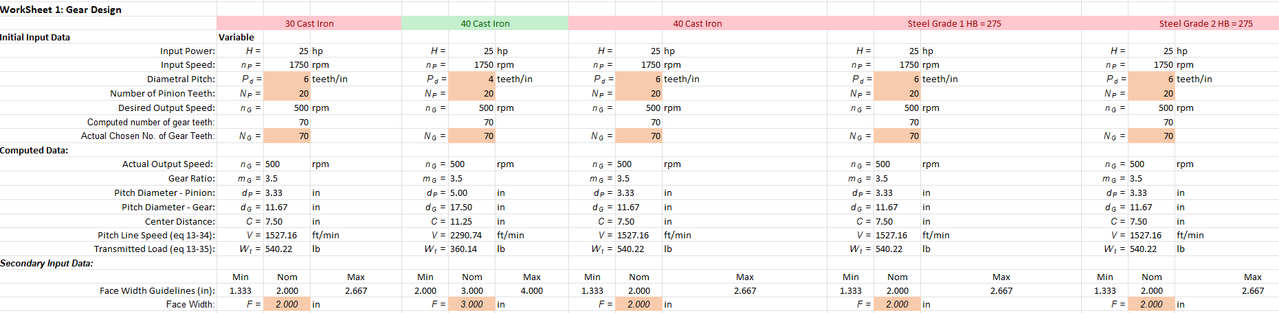

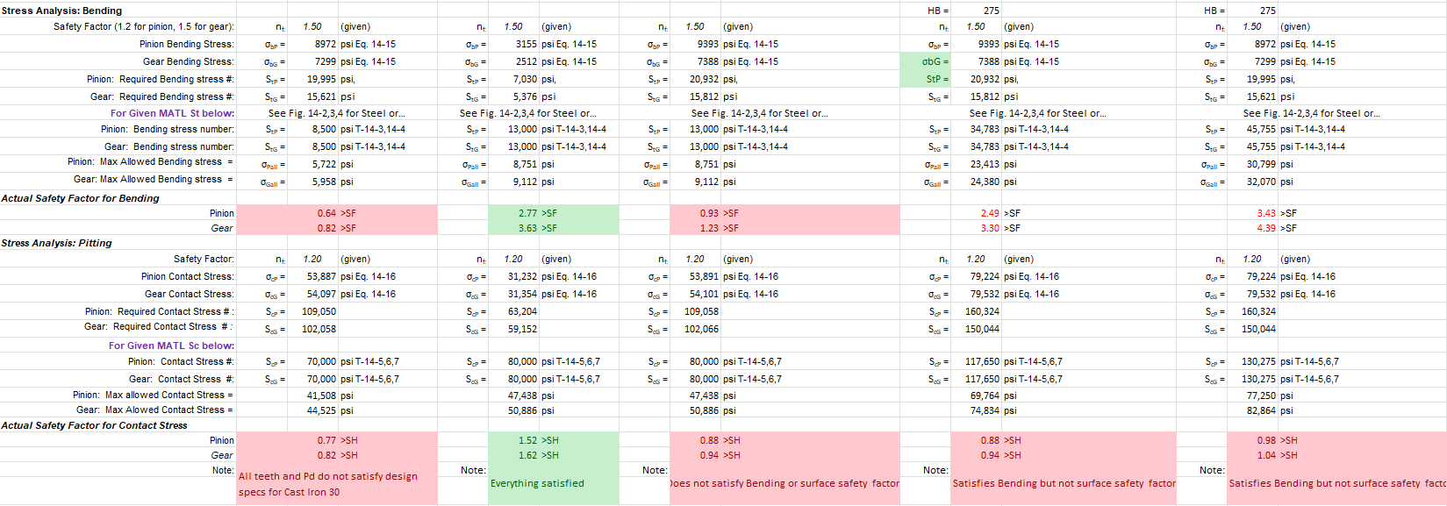

### Pinion Shaft

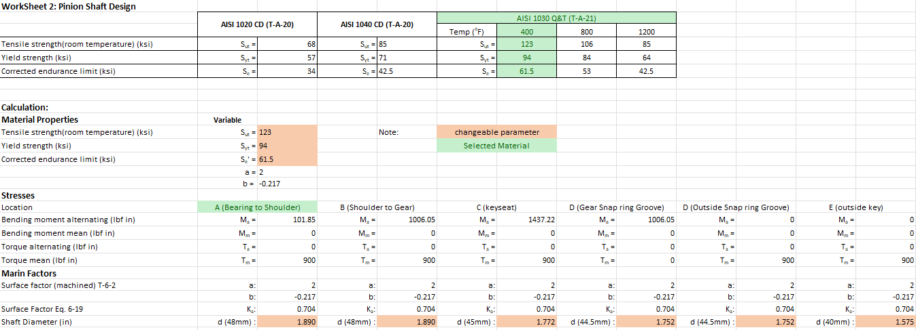

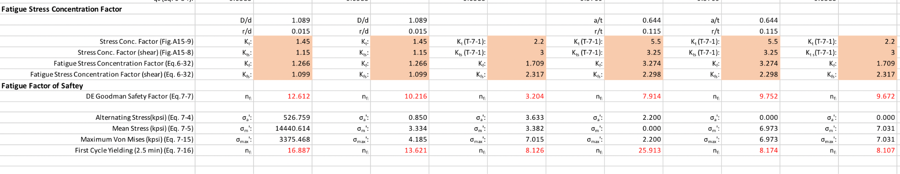

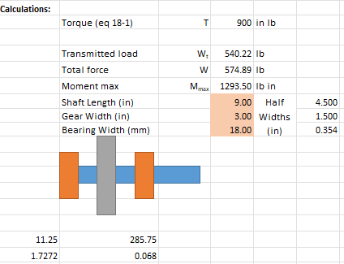

### Gear Shaft

### 

### 

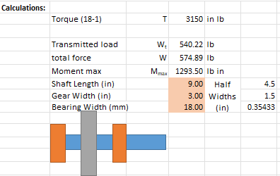

### 

### Key

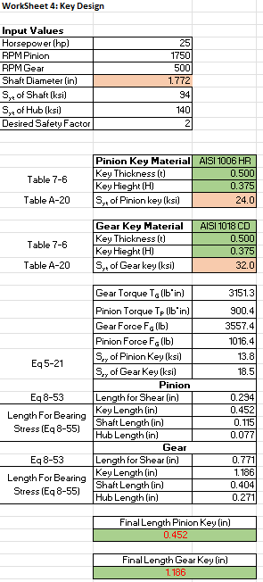

### Bearing

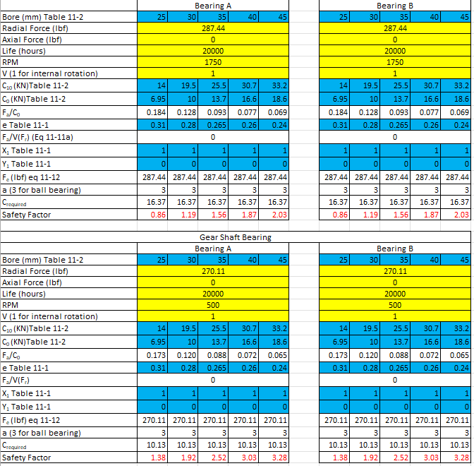

# References

Types of Gearboxes | Rexnord. (2012). Rexnord.com. <https://www.rexnord.com/blog/articles/gear/types-of-gearboxes>

TMechanical Systems and Signal Processing | 2022 Elsevier B.V., <https://www.sciencedirect.com/science/article/abs/pii/S0888327016303168>

ResearchGate Ovidiu Buiga | 2012 July, <https://www.researchgate.net/figure/The-sketch-of-the-single-stage-helical-gear-unit_fig2_289230457>

ResearchGate Yongsheng Ma | 2012 August,

<https://www.researchgate.net/figure/An-example-of-gearbox-layout-1-pinion-1-2-bearing-1-3-connecting-bolt-for-bearing_fig1_257601771>

Gear Motions Precision in Motions | 2022,

<https://gearmotions.com/helical-gears-vs-spur-gears/>

# Appendices

## Appendix A: List of Symbols

$C_{f}$ Surface condition factor

$C_{H}$ Hardness-ratio factor (gear only)

$C_{P}$ Gear elastic coefficient

$C_{10}$ Bearing catalogue load rating

$d_{P}, d_{G}$ Pitch diameter of pinion and gear, respectively

$E$ Young’s Modulus

*F* Face width

*H* Input power

*I* Surface-strength geometry factor

$J_{P}$, $J_{G}$ Bending-strength geometry factor for pinion and gear, respectively

$K_{B}$ Rim thickness factor,

$k_{a}, k_{b}, k_{c}, k_{d}, k_{e}$ Marin factors for fatigue loading

$K_{m}$ Load distribution factor,

$K_{o}$ Overload factor,

${\left(K_{s}\right)}_{P}$, ${\left(K_{s}\right)}_{G}$ Size factor for pinion and gear, respectively

$K_{R}$ Gear design reliability factor

$K_{T}$ Gear design temperature factor

$K_{v}$ Dynamic Factor,

$N_{P}, N_{G}$ Number of teeth of pinion and gear, respectively

$m_{G}$ Gear ratio

*n*  Input velocity

*N* Life cycles

$P_{d}$ Diametral pitch

*R* Reliability

$S_{c}$ Contact strength number for cast iron

$S_{e}$ Corrected endurance limit

$S_{e}^{’}$ Uncorrected endurance limit

${\left(S_{H}\right)}_{P}$, ${\left(S_{H}\right)}_{G}$ Safety factor for contact stress

${\left(S_{F}\right)}_{P}, {\left(S_{F}\right)}_{G}$ Safety factor for bending

$S_{t}$ Unadjusted bending stress number

$S_{ut}$ Ultimate tensile strength

$S_{yt}$ Tensile yield strength

$T$ Torque

${\left(Y_{N}\right)}_{P}$, ${\left(Y_{N}\right)}_{G}$ Stress cycle factor for bending stress

$V$ Pitch line velocity

$v_{P}, v_{G}$ Poisson’s ratio for pinion and gear

$W^{t}$ Transmitted load

${\left(Z_{N}\right)}_{P}$, ${\left(Z_{N}\right)}_{G}$ Stress cycle factor for contact stress

$ϕ$ Pressure angle for spur gear

$ϕ_{t}$ Transverse pressure angle

$ϕ_{n}$ Normal pressure angle

$ψ$ Helix angle

${\left(σ\right)}_{P}$, ${\left(σ\right)}_{G}$ Bending stress on pinion and gear, respectively

${\left(σ_{C}\right)}_{P}$, ${\left(σ_{C}\right)}_{G}$ Tooth wear (contact stress) for pinion and gear

## 

## 

**

## Appendix C: Figures

## Appendix C: EquationsText Description automatically generated with medium confidenceGraphical user interface Description automatically generated with medium confidenceBackground pattern Description automatically generated with low confidenceDiagram Description automatically generatedApplication Description automatically generated with low confidenceDiagram Description automatically generated with medium confidenceBackground pattern Description automatically generated with low confidenceBackground pattern Description automatically generated with low confidenceBackground pattern Description automatically generated with low confidenceGraphical user interface Description automatically generated with low confidenceA picture containing text Description automatically generatedGraphical user interface, text Description automatically generated with medium confidenceA picture containing Word Description automatically generatedA picture containing graphical user interface Description automatically generatedText Description automatically generated with medium confidenceA picture containing diagram Description automatically generatedText Description automatically generatedA picture containing diagram Description automatically generated

